**Data Analytics SQL Mini Project -L1**

I created a new database called "kp" and I'm using it for this project.

– *create database kp* – *use* ***kp****;*

Insight number 1 -- Reading the whole table select * from cars24

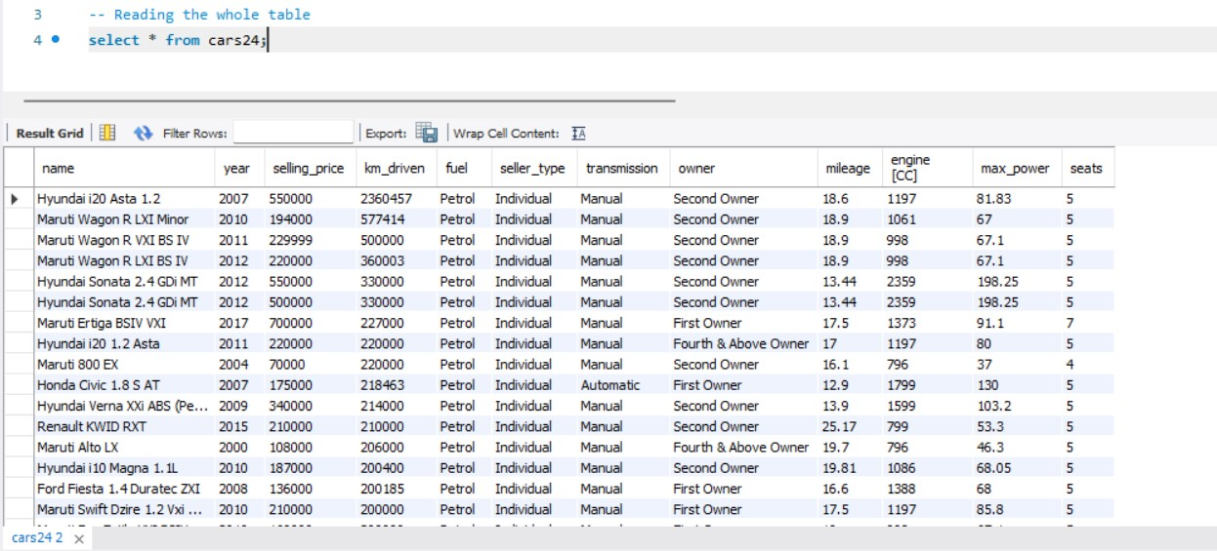

# Insight number 2 -

-- counting the total number cars present in the data set select count(*) from cars24

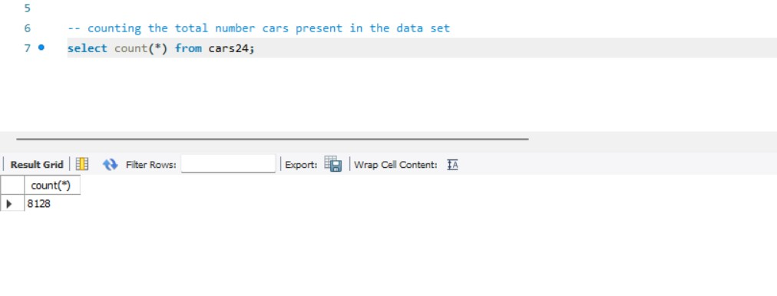

Insight number 3 -- unique fuel types in this table select distinct fuel from cars24;

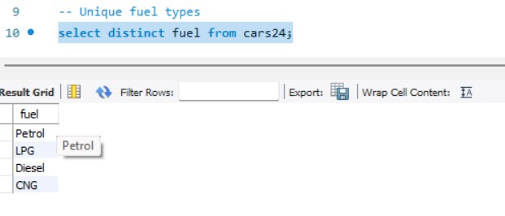

Insight number 4 -- Average kilometer driven by cars select avg(km_driven) as avg_km_driven from cars24;

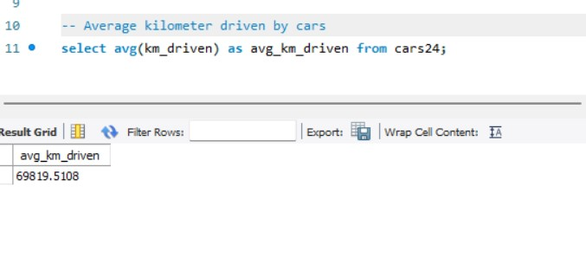

# Insight number 5 -

-- 10 car model driven the most on average

select name, avg(km_driven) as avg_km_driven from cars24 group by name order by avg_km_driven desc

limit 10;

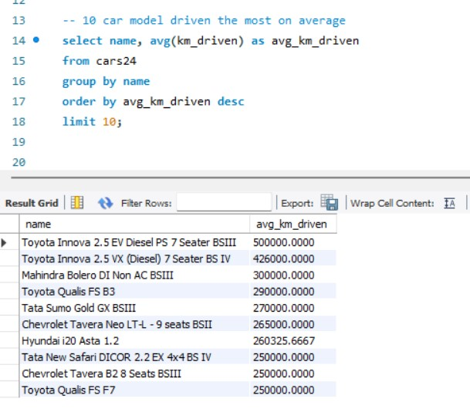

Insight number 6 -- Top 10 popular car model

select name, count(*) as cnt from cars24 group by name

order by cnt desc, limit 10;

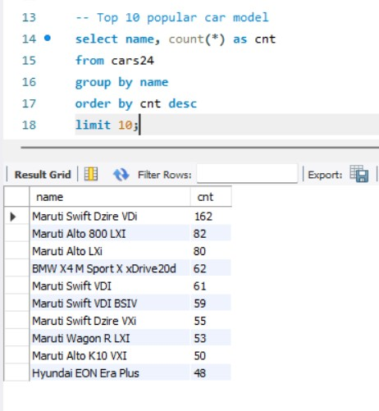

# Insight number 7 -

-- Average selling price of different car models

select name, avg(selling_price) as avg_selling_price from cars24 group by name

order by avg_selling_price desc;

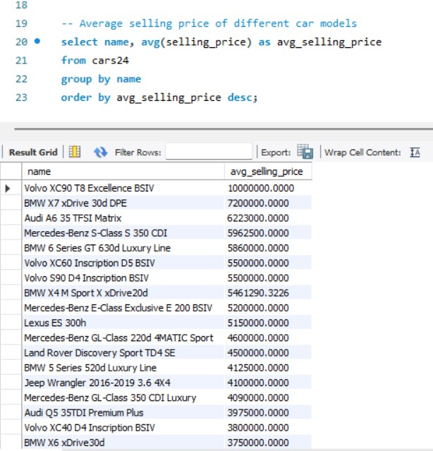

# Insight number 8 -

-- Numbers of cars sold by each seller type

select seller_type, count(*) as cars_sold from cars24 group by seller_type order by seller_type asc;

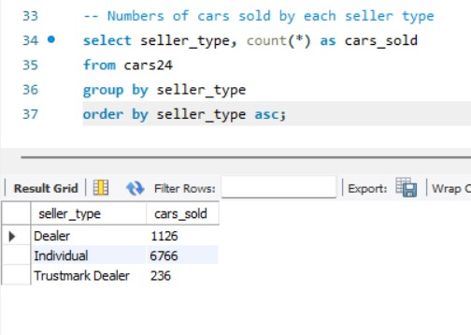

# Insight number 9 -

-- Total number of milage covered by cars with name 'Audi'

select sum(mileage) as audi_milage from cars24 where name like '%Audi%';

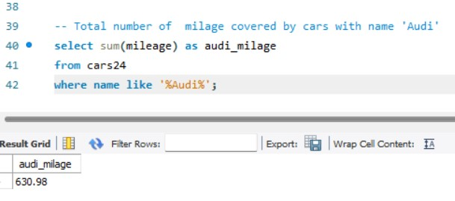

# Insight number 10 -

-- Cars sold by each seller_type with higher than 50000 selling price

select seller_type, count(*) as cnt from cars24 group by seller_type having sum(selling_price) > 50000 order by seller_type asc;

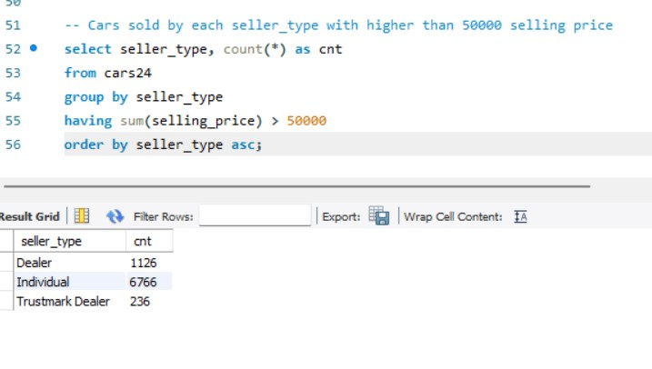

# Insight number 11 -

-- Cars sold by each transmission type with lower than 12000 km driven

select transmission, count(*) as cnt from cars24 where km_driven < 12000 group by transmission order by transmission;

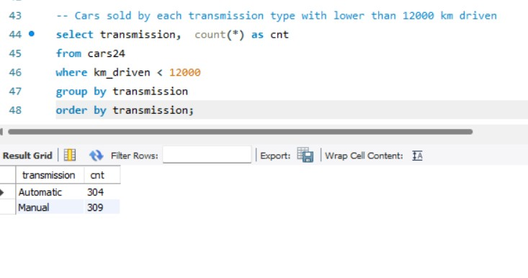

# Insight number 12 -

- Cars sold by 'dealear' seller type having 'maruti' in their name

select seller_type, name, count(*) as cnt from cars24 where seller_type = 'dealer' and name like '%maruti%' group by seller_type, name order by seller_type asc;

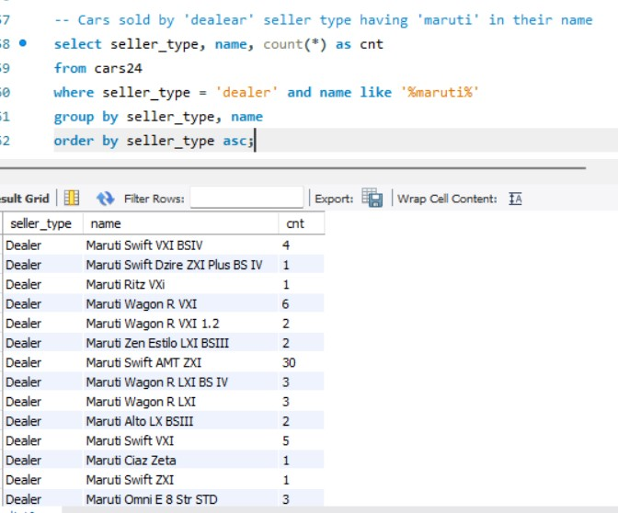

Insight number 13 -- Car with the highest mileage

select name, mileage from cars24 where mileage = (select max(mileage) from cars24);

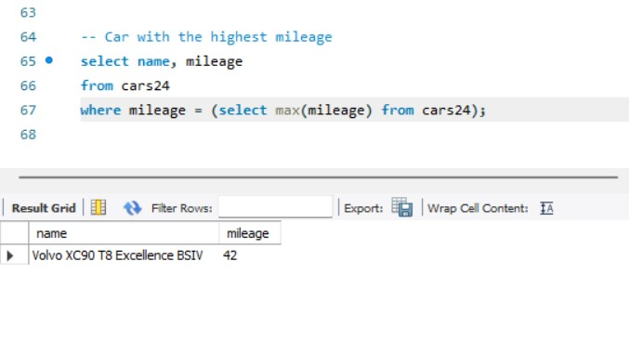

Insight number 14 -- Car with the lowest mileage

select name, mileage from cars24 where mileage = (select min(mileage) from cars24) limit 10;

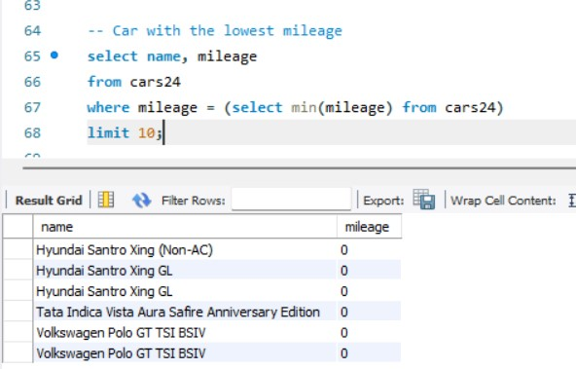

# Insight number 15 -

-- Average selling price of cars manufactured year

select name, year, avg(selling_price) as avg_selling_price from cars24 group by name, year order by year asc

# limit 10;

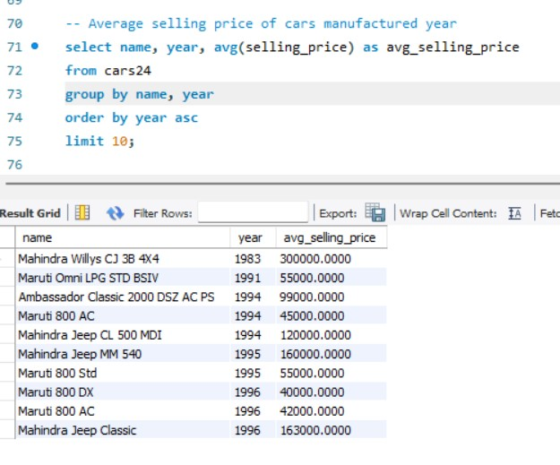

## Insight number 16 -

-- Highest selling-price of car models across year

select name, year, avg(selling_price) as avg_price from cars24 group by name, year order by avg_price desc limit 10;

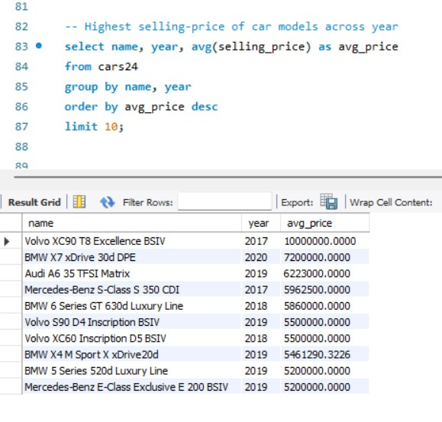

## Insight number 17 -

-- Cars with more seats having average mileage

select seats, name, avg(mileage) as avg_mileage from cars24 group by seats, name order by seats desc

# limit 5;

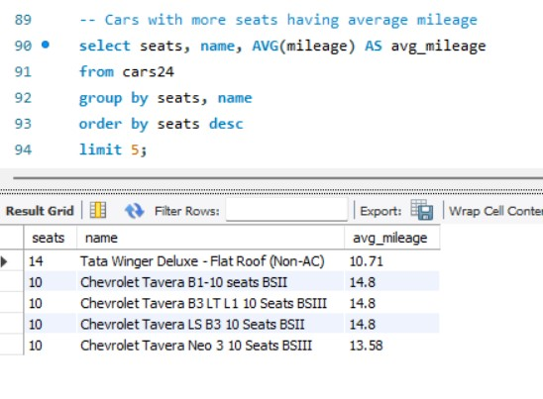

## Insight number 18 -

-- Average selling price of cars with seats more than 8

select name, seats, avg(selling_price) as avg_sellling_price from cars24 where seats >= 8 group by name, seats order by seats desc

# limit 15;

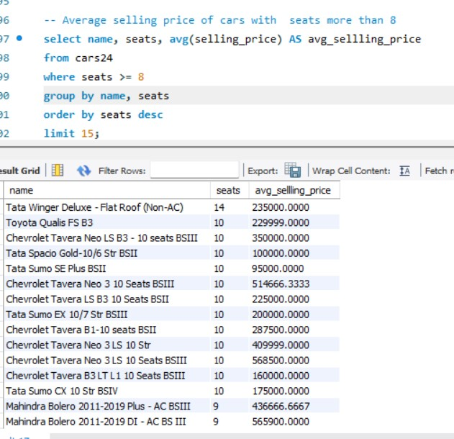

## Insight number 19 -

-- Kilometers driven for cars sold by individual sellers compared to dealers

select seller_type, min(km_driven) as min_km, max(km_driven) as mx_km, avg(km_driven) as avg_km from cars24 group by seller_type order by seller_type asc;

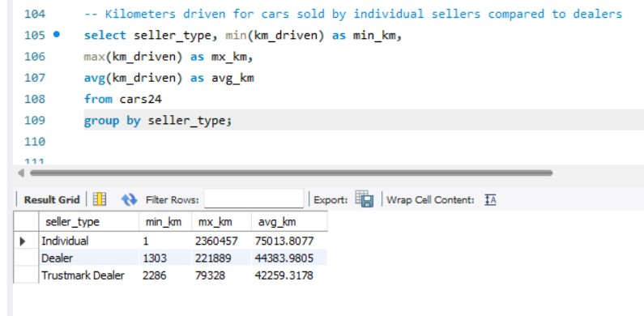

## Insight number 20 -

-- car models with consistently low mileage across different years

select name, year, mileage from cars24 where mileage < (select avg(mileage)from cars24) order by name, year

# limit 10;

